SOCCER
METEOR
DE LA SALLE INSTITUTE



School Colors: Royal/Gold
Home Jersey: Royal
Away Jersey: White
Nickname: Meteors
Head Coach: Francisco Martinez
Assistant Coach: Carlos Nuñez
President: Michael Zunica
Principal: Thomas Schergen
Athletic Director: Tom White
School phone: 1-312-842-7355

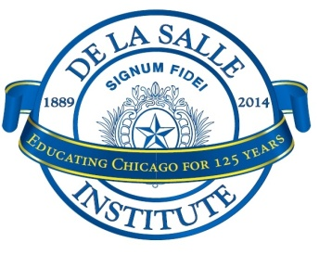
De La Salle Institute 2024 Varsity Boys Soccer Roster
No. | Name | Year | Position | Grammar School
16 | Jon-Philip Tiller | 12 | D/M | STEM Magnet Academy
4 | Tim Schergen | 12 | D/F | Central Jr. High (Evergreen Park)
30 | Mario Ramirez | 12 | M/F | Horizon Science Academy
7 | Agustin Ortega | 12 | F | Irene C. Hernandez Achievement
10 | Brandon Olvera | 12 | M/F | Perez, Manual
49 | James Mountifield | 12 | M | Kenwood Academy
23 | Kenyan Edwards | 12 | M | Kenwood Academy
18 | Bryan Tamayo | 12 | F
0 | Andrew Martinez | 12 | GK
1 | Jahir Anaya | 11 | GK | Gary Elementary, Joseph E.
9 | Fidel Orozco | 11 | M/F | Evergreen Middle Academy
5 | Nathan Gutierrez | 11 | D | Perez, Manual
6 | Alex Panduro | 11 | M/F | Our Lady of Charity
11 | Evan Miranda | 11 | M/F | Gunsaulus Scholastic Academy
2 | Christopher Dingle | 11 | D/M | Old St. Mary's (Michigan Av)
12 | Cesar Solano | 11 | D/M | Memorial Junior High
24 | Antonio Sanchez | 11 | D/M
14 | Antonio Als | 10 | M/F | Stem Magnet Academy
3 | Christian Edwards | 10 | D/M | Ray Elementary
17 | Christian Flores | 10 | M/F | Orozco Community Academy
15 | Fernando Orozco | 10 | M/F
19 | Joshua Lawson | 10 | M/F | Academy For Global Citizenship
31 | Kevin Gates | 10 | D/F | Murray Language Academy
13 | Miguel Huerta | 10 | M/F | San Miguel
8 | Tristan Tapia | 10 | D/M | Daystar Academy

