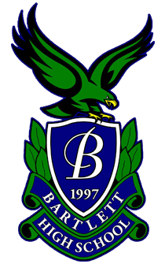
Bartlett High School
2026-27 Boys’ Varsity Soccer

Head Coach: Anthony Glorioso (anthonyglorioso@u-46.org)
Assistant Coach: Mark Mirsky (coachmirsky@gmail.com)
Managers: Gabby Abate, Amelia Medvid and Anais Vazquez
JV Head Coach: Hernan Garcia
Freshman Head Coach: Kevin Nava
JV2 Head Coach: Anthony Metallo
Athletic Director: Jeff Bral (jeffbral@u-46.org)
# | Name | Pronunciation | Pos. | Year
00 | Wojciech Furmaga | fur-MAH-guh | GK | SO.
0 | Eric Martinez | mar-TEEN-ezz | GK | SR.
3 | Jonathan Ocampo | oh-KAHM-poh | D | JR.
4 | Carlos Perez | per-EZZ | D | SR.
6 | Santiago Hernandez | her-NAN-dez | M | JR.
7 | Antonio LaGioia | lah-GEE-oy-uh | F/D | SR.
8 | Oliver Bicocchi | Bee-kok-kee | M | JR.
9 | Maximilian Acevedo | ah-seh-VAY-doh | F | SO.
10 | Sammy Kopanicak | koh-PAN-eh-sak | M | JR.
11 | Alan Villafuerte | villa-FWHERE-tay | F/D | SR.
14 | Jair Berrum | BEAR-um | F | SR.
15 | Edwin Santillan | an-tee-YAHN | M | SR.
16 | Rodrigo Vasquez | VAS-kez | M/D | SR.
17 | Patryk Linski | lin-SKEE | F | JR.
18 | Ruben Jimenez | hee-MEH-nez | F | SO.
19 | Brandon Woods | WOODS | F | JR.
20 | Logan Thompson | TOMP-suhn | M | SR.
21 | Mariano Cinardi | chee-NAR-dee | F | JR.
22 | Kaden Chow | CHOW | F | SR.
23 | Max Fowler | FOUL-err | D | JR.
24 | Nathan Ciolino | chee-oh-LEE-noh | D | JR.

