SOCCER
METEOR
DE LA SALLE INSTITUTE


School Colors: Royal/Gold
Home Jersey: Royal
Away Jersey: White
Nickname: Meteors
Head Coach: Francisco Martínez
Assistant Coach: Carlos Nuñez
Assistant Coach: Tom Schergen
Assistant Coach: Julio Martine
Assistant Coach: Antonio Maldonado
President: Michael Zunica
Principal: Tom Schergen
Athletic Director: Tom White
School phone: 1-312-842-7355

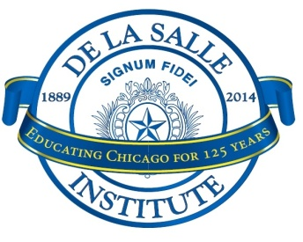
De La Salle Institute 2026 Varsity Boys Soccer Roster
No. | Name | Year | Position | Grammar School
14 | Antonio Als | 12 | M/F | Stem Magnet Academy
3 | Christian Edwards | 12 | D/M | Ray Elementary
10 | Christian Flores | 12 | M/F | Orozco Community Academy
21 | Fernando Orozco | 12 | D/M/F | Freedom
19 | Joshua Lawson | 12 | M/F | Academy For Global Citizenship
31 | Kevin Gates | 12 | D/F | Murray Language Academy
12 | Miguel Huerta | 12 | M/F | San Miguel
9 | Tristan Tapia | 12 | D/M | Daystar Academy
22 | Aaron Soto | 12 | M | St. Gall
2 | Emerson Costello-Stebelton | 12 | M | Percy Julian Middle School
7 | Jose Bamba-Bonifacio | 12 | M/F | Richard Career Academy
1 | Kobe Ibarra | 12 | GK | Unity Junior High School
24 | Miguel Perez | 11 | F | Veterans Memorial Middle School
11 | Anthony Vega | 10 | D/M | St. Procopius
8 | Jonathan Glass | 10 | D/M | Jungman
17 | Cristiano Loza | 9 | M/F | St. Thomas More
13 | Mared Martinez | 9 | M/F | Horizon Science Academy Southwest
15 | Andy Preciado | 9 | M/F | Sawyer
16 | Alejandro Solano-Mauro | 9 | M/F | Bartolome de Las Casas
20 | Levi Mora | 9 | M/D | Franklin Fine Arts Center
6 | Kris Anderson | 9 | D/M | St. Thomas More
18 | Aaron Diaz | 9 | D | Our Lady of Tepeyac
4 | Julian Martinez | 9 | GK | Bartolome de Las Casas

